# Module 2 – Contributing to a team



## Module 2 objectives

At the end of this module, you will be able to…

* talk about yourself and others.
* use personality adjectives.
* write a social media profile.
* talk about why working in a team is effective.
* talk about different types of teams.
* evaluate which is better: working in a team or working individually.
* talk about different ways of working.
* talk about the advantages of having different types of people on a team.
* talk about how to form teams.
* tell an anecdote.
* talk about solving a problem and present a solution.
* use Java terminology in English (call, directory, shared file, code).

**Lesson 1 – Who am I? Who are you?**

## Lesson 1 objectives

At the end of this lesson, you will be able to…

* talk about yourself and others.
* use personality adjectives.
* write a social media profile.

## Activate

Discuss with a partner. Share your answers with the rest of the class.

* What words would you use to describe yourself?
* Why is it important to know about your personality?
* Do we use nouns, adjectives, adverbs, or verbs to describe personality?

## Learn



1. Work with a partner. Listen to the segment from the radio show. What is it about?

1. Work with a partner. Read the following statements. Are they **true** or **false**? Correct the sentences that are false.

1. The most important thing a company looks for in a prospective employee is their ability to use a computer.
2. Companies prefer individualistic people for their teams.
3. For a company, it does not matter if an employee does not fit into their work culture.
4. You have to be careful of the way you describe yourself to a prospective employer.
5. It is OK to post photos on your social media profile which show you engaging in irresponsible behavior.
6. It is important to be authentic in your social media profile.

Read audio script 2.1 at the end of this module to check your answers.

3. Work with a partner. Use a dictionary. Match the following adjectives from the audio with their synonyms and write the opposite of the adjective in column C. Look at the example.

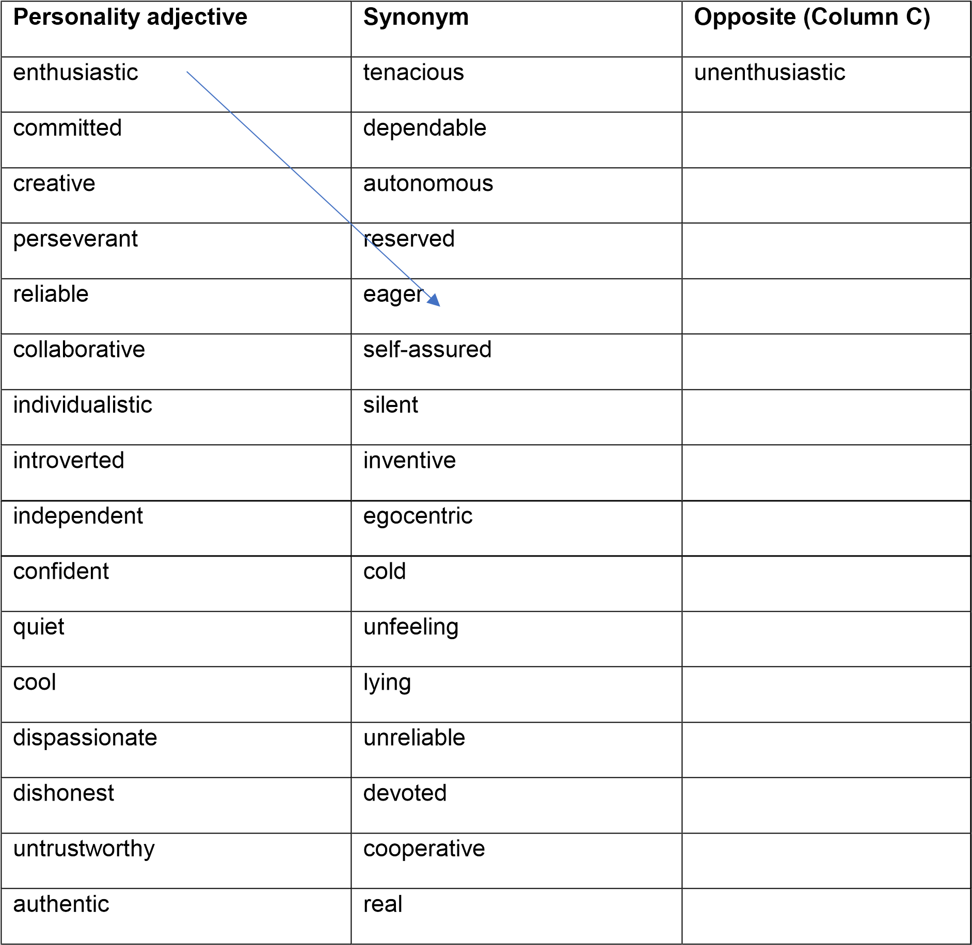

## Do

4. Work individually. Complete the following sentences so that they are true for you. Use some of the adjectives from Activity 3. When you have finished, compare your sentences with a partner. Are your sentences the same or different?

1. When I work in a team, I’m…
2. When I get up in the morning, I’m…
3. When I go for a job interview, I’m…
4. When I have a problem, I’m…
5. When I commit to something, I’m…
6. When I don’t agree with someone, I’m…

**Let’s use it!**

1. Use the advice from the audio to complete the following social network profile about yourself.

|  |  |  |
| --- | --- | --- |
|  | |  | | --- | | Photo:      Name:  Profession:  Description of you:      Skills:      Interests:      The kind of job you’re looking for: | |

1. Post your profile on the class Wiki. Vote for the most effective profile. Justify your vote.

**How did I do? Evaluate yourself.**

|  |  |  |  |  |
| --- | --- | --- | --- | --- |
|  | **I can’t yet…** ☹ | **More or less (-)** | **Yes, I can!** 😊 | **If you need help, go to…** |
| I can use personality adjectives. |  |  |  | Activity 3 |
| I can talk about myself and others. |  |  |  | Activity 4 |
| I can write an effective social media profile in English. |  |  |  | Activity 5 |

**I am competent!**

Self-awareness is a useful competency for the workplace. When we know ourselves, we can see our strengths and weaknesses. We can also understand better how others see us. This helps us to work more effectively in a team.

Did you discover anything interesting about yourself in this lesson? Write your thoughts in your portfolio. If you wish, you can show what you wrote to a partner, or you can keep it private.

**Lesson 2 – Why does working in a team get results?**



## Lesson 2 objectives

At the end of this lesson, you will be able to…

* talk about why working in a team is effective.
* talk about different types of teams.
* evaluate which is better: working in a team or working individually.

## Activate

Discuss with a partner. Share your answers with the rest of the class.

* Why might working in a team get better results than working individually?
* Can you remember a successful team you were part of?
* What different types of team can you think of?

## Learn

1. Work with a partner. Read the following text about why team work is effective. Why does working in a team get better results than working individually?

When we think about success, we often think of a skilled individual who has worked hard. Someone with lots of talent who dazzles the world with their brilliance. A star. However, research has shown that the most successful people are those who can work with others because a group can get more done than one person. One person can only achieve so much. A team of people working together can achieve so much more.

Part of the reason for this can be explained in the concept of division of labor. This is a very old concept that can be even observed in ancient civilizations. The idea goes like this. An individual only has a certain number of productive hours per day to achieve results. If you have a group of people working on the same project, then the results achieved by one person can be multiplied by the number of people in the group. In short, a group of people working in unison gets a lot more done than just one person.

Another reason that teams are successful is that no one person can be good at everything. This is impossible. It is not possible to find all the skills and talents needed to make a successful project happen in one individual. It is a team of people with different skills and talents that makes something great. And this working together is even more powerful when the people on the team realize that their different strengths complement the weaknesses that each person has.

The model of people working together to achieve things can be seen all over the place. Imagine how boring football would be if it was an individual sport. Famous companies would never be famous without hundreds or even thousands of individuals working hard together to produce something or deliver a service. Historic rock groups would never have made such great music without their special combination of personalities and skills.

2. Work with a partner. Read the text again and answer the following questions. Justify your answers.

1. In paragraph 1, it says that successful people are those who can…
   1. work of a group. ii. work in a group. iii. work on a group.

iv. work outside of a group.

1. In paragraph 1, it says that teams achieve…
   1. more than an individual. ii. less than an individual. iii. the same as an individual.

iv. more or less the same as an individual.

1. In paragraph 2, it explains that division of labor is…
   1. the idea that a person can achieve what the number of people in the group can achieve.
   2. the idea that a group of people can achieve what one person can achieve, multiplied by the number of people in that group.
   3. the idea that a group of people is smaller than one person.
   4. the idea that a group of people is bigger than one person.

1. In paragraph 3, it explains that a team can be effective because it has…
   1. people who are not good at anything.
   2. people with different skills, talents, strengths, and weaknesses, which all complement each other.
   3. people with different skills, talents, strengths, and weaknesses.
   4. one person who is good at everything.

1. Paragraph 4 give us…
   1. examples of successful teams. ii. examples of groups of people.

iii. information about teams. iv. examples of famous people.

## Do

1. Work with a partner. Analyze the vocabulary in the text in Activity 1 and complete the graphic organizer to help you learn and remember new words connected with team work.

Team

work

**Adjectives**

-

successful

powerfull

famous

**Adverbs**

-

together

individually

**Nouns**

-

group

Team

**Verbs**

-

work with

Analyze

others

**Let’s use it!**

1. Work with a partner. Working in a team is a great way of getting a lot done. However, it is not the only way of working. Investigate online and fill out the table below. Which is better: working individually or working in a team? Post your lists and your opinions on the class Wiki.

|  |  |  |  |
| --- | --- | --- | --- |
| **Advantages of working in a team** | **Examples** | **Advantages of working individually** | **Examples** |
| Work gets easy | divide the tasks | You manage your own time | Self managment |
| Maximizes productivity | Combine everybody’s strengths and areas of expertise | [determine their own goals](http://toggl.com/blog/project-objectives/) | You put your own deadlines. |
| More diferents ways to do the same work | Share ideas |  |  |
|  |  |  |  |
|  |  |  |  |

**How did I do? Evaluate yourself.**

|  |  |  |  |  |
| --- | --- | --- | --- | --- |
|  | **I can’t yet…** ☹ | **More or less (-)** | **Yes, I can!** 😊 | **If you need help, go to…** |
| I can talk about why working in a team is effective. |  |  |  | Activities 2 & 4 |
| I can talk about different types of teams. |  |  |  | Activities 2 & 4 |
| I can evaluate which is better: team work or working individually. |  |  |  | Activity 4 |

**I can learn!**

Using graphic organizers and lists is a good way of analyzing information. You practiced using them in Activities 3 and 4.

Work with a partner. Think about the other areas of your course with Generation. How could you use graphic organizers and lists to help you study? Write your ideas in your portfolios.

# Lesson 3 – Roles on a work team



## Lesson 3 objectives

At the end of this lesson, you will be able to…

* talk about different ways of working.
* talk about the advantages of having different types of people on a team.
* talk about how to form teams.

## Activate

Work with a partner. Using your ideas, try to answer the following questions.

* What are the advantages of having different types of people on a team?
* Might it be dangerous if everyone on a team had the same ideas?
* How can we make sure that a team has different types of people?
* How can we know what types of people we want on our team?

## Learn

1. Work with a partner. Use the information in the text to check your answers to the questions in the Activate section.

A successful team has many different types of people. Each one of us has specific strengths and weaknesses. Everyone is different. The strengths of others on our team complement our weaknesses and vice versa. For example, some people are good with numbers but are terrible at communicating with others. Other people on the team might be great communicators but they are terrible with numbers. It is the union of complementary strengths that makes a team great. A football team is a great analogy. Everyone on a football team has a different role. The goal keeper should not play a forward position. And likewise, you do not see a forward in the goal.

Another way that teams are diverse is in the way people prefer to work. Some people do not like paying attention to detail. They are more creative. It would be a mistake to give a job that requires a lot of attention to detail to someone who does not like paying attention to detail. It is better to put them working on something they like to do and find a person who likes paying attention to detail for the tasks that require this. These different ways of working complement each other and make the team stronger.

This diversity on a team is also a strength for a team in that it helps us avoid groupthink. Groupthink was a term invented by psychologist Irving Janis in 1972. He noticed that when everyone in a group is similar, they tend to make bad decisions. They tend to feel invulnerable and are excessively optimistic. And because everyone is encouraged to think the same, anyone with a different view is reluctant to express it. This means that warnings are ignored and the team is not creative.

The first step to ensuring that you have a variety of different types of people on your team is by celebrating diversity. By recognizing that different opinions and different ways of working on a team are something to be celebrated, you are making an important statement about how you want your team to work. The next step to having a diverse team is in how you put the team together. When you are selecting people to join the team, make sure you choose people who are different from each other and whose skills and ways of working complement each other in a positive way.

A fundamental element we should consider when putting together a team is what kind of people we want on that team. You should make a list of the different skills the team needs, identify people with those skills and invite them to join the team. Meredith Belbin is a British management theorist who discovered that the most successful teams are those with nine specific roles based on different ways of working. He states that it is crucial to include these roles in every work team if it is to be successful.

2. Work with a partner. Fill out the following table with information from the text.

|  |  |
| --- | --- |
| Advantages of having different types of people on a team | Diversity of ideas, opinions and skills |
| Danger of having people on a team who think the same | Groupthinking. |
| How we make sure that we have different types of people on our team | celebrating diversity. |
| How we know what kind of people we want on our team | people whose skills and ways of working complement each other in a positive way. |

## Do

1. Work with a partner. Read the text again and answer the following questions. Share your answers as a class.

* 1. Apart from the examples given in the text, what kind of strengths and weaknesses might people on a work team have?
  2. What do you think the author of the text means when they refer to the way people prefer to work?
  3. Have you ever experienced Groupthink in university or in a job? What happened exactly?
  4. What kind of differences of opinion might people have on a work team?
  5. What skills would a team of computer programmers need?

**Let’s use it!**

1. Work individually. Do the following task to discover how you like to work. When you have finished compare your answers with a partner. Are you similar or different? Did you learn anything about yourself by doing the activity?

|  |  |  |  |  |  |  |  |  |  |  |  |  |  |  |  |  |  |  |  |  |  |
| --- | --- | --- | --- | --- | --- | --- | --- | --- | --- | --- | --- | --- | --- | --- | --- | --- | --- | --- | --- | --- | --- |
|  | |  |  | | --- | --- | | **Way of working** | **√** | | a. I make sure that everyone in the team gets on with each other. |  | | b. I love tasks where I need to come up with ideas. |  | | c. I like to investigate what’s happening in the world. |  | | d. I like assigning tasks to people. |  | | e. I like leading others. |  | | f. I like evaluating how we are doing as a team. |  | | g. I love planning. |  | | h. I love working on tasks that require attention to detail. |  | | i. I like being an expert and giving advice to others. |  | |

**How did I do? Evaluate yourself.**

|  |  |  |  |  |
| --- | --- | --- | --- | --- |
|  | **I can’t yet…** ☹ | **More or less (-)** | **Yes, I can!** 😊 | **If you need help, go to…** |
| I can talk about different ways of working. |  |  |  | Activities 2,3 & 4 |
| I can talk about the advantages of having different types of people on a team. |  |  |  | Activity 2, 3 & 4 |
| I can talk about how to form teams. |  |  |  | Activities 2 & 3 |

**I am competent!**

The ability to work with different types of people is called intercultural competency. If you have a high level of intercultural competency, you can work easily with people who think and behave differently from you.

How good is your intercultural competency? How do you know? Write your ideas in your portfolio.

# Lesson 4 – Solving a problem together



## Lesson 4 objectives

At the end of this lesson, you will be able to…

* tell an anecdote.
* talk about solving a problem.

## Activate

Discuss the following questions with a partner.

* Do you like solving problems? Why/why not?
* What is the best way of solving a problem in your opinion?
* If you have a problem, what is the best way to react emotionally?

## Learn



1. Work with a partner. Listen to the audio. Identify the problem and the solution. Compare your answers as a class.

1. Work with a partner. Listen to the audio a second time. Decide if the following sentences are **true** or **false**. Correct the sentences that are false.

1. The person telling the anecdote was a marketing manager for all of the products at the pharmaceutical company.
2. He decided to go for a walk because he needed to get some exercise.
3. His solution involved team work with another marketing manager from the same company.
4. His solution was so successful that the two marketing managers have decided to continue working together at other events.

Read audio script 2.2 at the end of this module to check your answers.

## Do

3. Work with a partner. Put the following phrases from audio script 2.2 into the correct chronological order. Look at the examples. What tense are the phrases in (present, past, or future)? Write a translation of the phrases into Spanish in your portfolios. Use a dictionary to help you.

* I was working as marketing manager in a pharmaceutical company. (1)
* It was terrible.
* We reduced costs and increased promotion.
* I was in charge of a product for diabetes. (2)
* We decided to work together… • I went for a walk.
* Where was I going to display my products?
* I came up with an idea.
* I needed to think of a solution.
* We decided to work again this way.
* She promoted my products and I promoted hers.
* …the stand wasn’t going to arrive.
* We were participating in an important event. (3)
* I received news that…

**Let’s use it!**

1. Work individually. Think about a time you had a problem and you found a solution.

Make notes about what the problem was and the solution you found in the box below. Be sure to use past tense.

|  |
| --- |
|  |

1. Work with a partner. Tell each other your anecdotes. Be sure to use past tense.

**How did I do? Evaluate yourself.**

|  |  |  |  |  |
| --- | --- | --- | --- | --- |
|  | **I can’t yet…** ☹ | **More or less (-)** | **Yes, I can!** 😊 | **If you need help, go to…** |
| I can tell an anecdote. |  |  |  | Activities 3, 4 & 5 |
| I can talk about solving a problem. |  |  |  | Activities 4 & 5 |

|  |
| --- |
| **I am competent!**  How do we solve problems? When we have a problem, we need to get creative. Creativity is very important for when we need ideas. Without ideas, we cannot solve problems.  Think about how you came up with the idea for the solution to your problem in Activity 4. Did you do one of the following or something else? Write your ideas in your portfolio and compare what you write with a partner.   * I went for a walk to clear my head. * I played football or took some other form of exercise to get my creative juices flowing. * I bounced ideas off a friend. * I got some rest knowing that getting some sleep would help me to think more clearly. * I searched for solutions on the Internet. * I asked other members of my team for help. |

# Lesson 5 Product lesson

Java is a programming language used to create applications and platforms. It is based on the syntax of older languages C and C++ but it is easier to use. Java programmers often work in teams. Every day they meet with other members of their team to come up with solutions to problems they have. This communication as a team is also a way of avoiding duplication of effort.



Work in groups of three. Read the following Java programming case study and come up with a solution. You can investigate on the Internet. Video yourselves presenting your solution to the rest of the class and upload the recording onto the class Wiki. Be sure to use Java terminology. Vote for the best solution. Justify your vote.

Juan, a front-end developer and Yasmín, a back-end developer, are working together on a project for *Ahorramex*, a new bank in Mexico. They are using Java to program the platform the customers will use to access their bank accounts. Juan notices that a certain aspect of the functionality is not working. The problem is when a customer tries to transfer money from their personal account to an investment account. The error might be in front-end coding or back-end coding. How can Juan and Yasmín work together in a team to solve this problem?

## Evaluate the product lesson

|  |  |  |  |  |
| --- | --- | --- | --- | --- |
|  | **Could be better** ☹ | **More or less**  **(-)** | **Yes, we did it!**  😊 | **What we can do next time to improve** |
| My partners and I worked well as a team. |  |  |  |  |
| Our product was interesting for the rest of the class. |  |  |  |  |
| We learned something that we can apply to our real lives. |  |  |  |  |
| We used our research skills effectively. |  |  |  |  |
| We used Java terminology in English. |  |  |  |  |

**I can communicate!**

Work with a partner. Make a list of the Java and computer terminology that you used in the product lesson. How can you memorize this language so that you can use it in your future job?

**Audio scripts**

[Audio script 2.1]

Good morning and welcome to our show! This morning we’re going to talk about team work and specifically, we’re going to give you advice on writing a social network profile to sell yourself to an employer.

So, the idea of selling yourself to an employer isn’t new, but did you know that one of the most important things that companies look for today is your ability to work in a team. Companies want you to know what you can offer their team. They see you less as an individual and they want to make sure that you will fit into their work culture; and that you will work well with everyone else who works there.

So, what are the dos and don’ts of writing a social network profile to attract a prospective employer. Well, first you need to be careful of the image that you portray when you describe yourself. You need to make sure that you use adjectives that communicate that you’re a team player. Use adjectives like enthusiastic, committed, creative, perseverant, reliable and collaborative. Having a good sense of humor helps too. Try to show this in your profile. Don’t take yourself too seriously.

Be careful about using adjectives which describe a more individualistic personality such as introverted, independent, confident, quiet, cool, or dispassionate. These adjectives may make a company worry about if you’re going to fit in.

You also need to be careful about how you come across in your photos online. Do not post photos which show you doing anything dishonest or which might portray you as someone untrustworthy. Companies want to hire people they can trust. Be authentic too. Make sure that the person they are interviewing is the same as the person they can see online.

Well! I hope this information has been useful. Don’t forget to visit our website, where you’ll find more information on this topic. So, now, let’s take a short commercial break. We’ll be right back…

[Audio script 2.2] I’ll never forget the time I was working as marketing manager in a pharmaceutical company. I was in charge of a new product for diabetes and we were participating in an important conference for doctors. The night before the event, I received news that the stand wasn’t going to arrive. It was terrible. Where was I going to display my products and receive my clients? I needed to think of a solution fast. So, I went for a walk to clear my head and to get my creative juices flowing. After about 30 minutes walking, I came up with the idea of asking a colleague who was a marketing manager for another type of medicine if I could place my products and receive my clients on her stand. We decided to work together on the same stand and promote each other’s products. She promoted my products and I promoted hers. This solution worked so well that we decided to work this way again this year. This way we reduced costs for our company and we increased the amount of promotion for each other’s products.